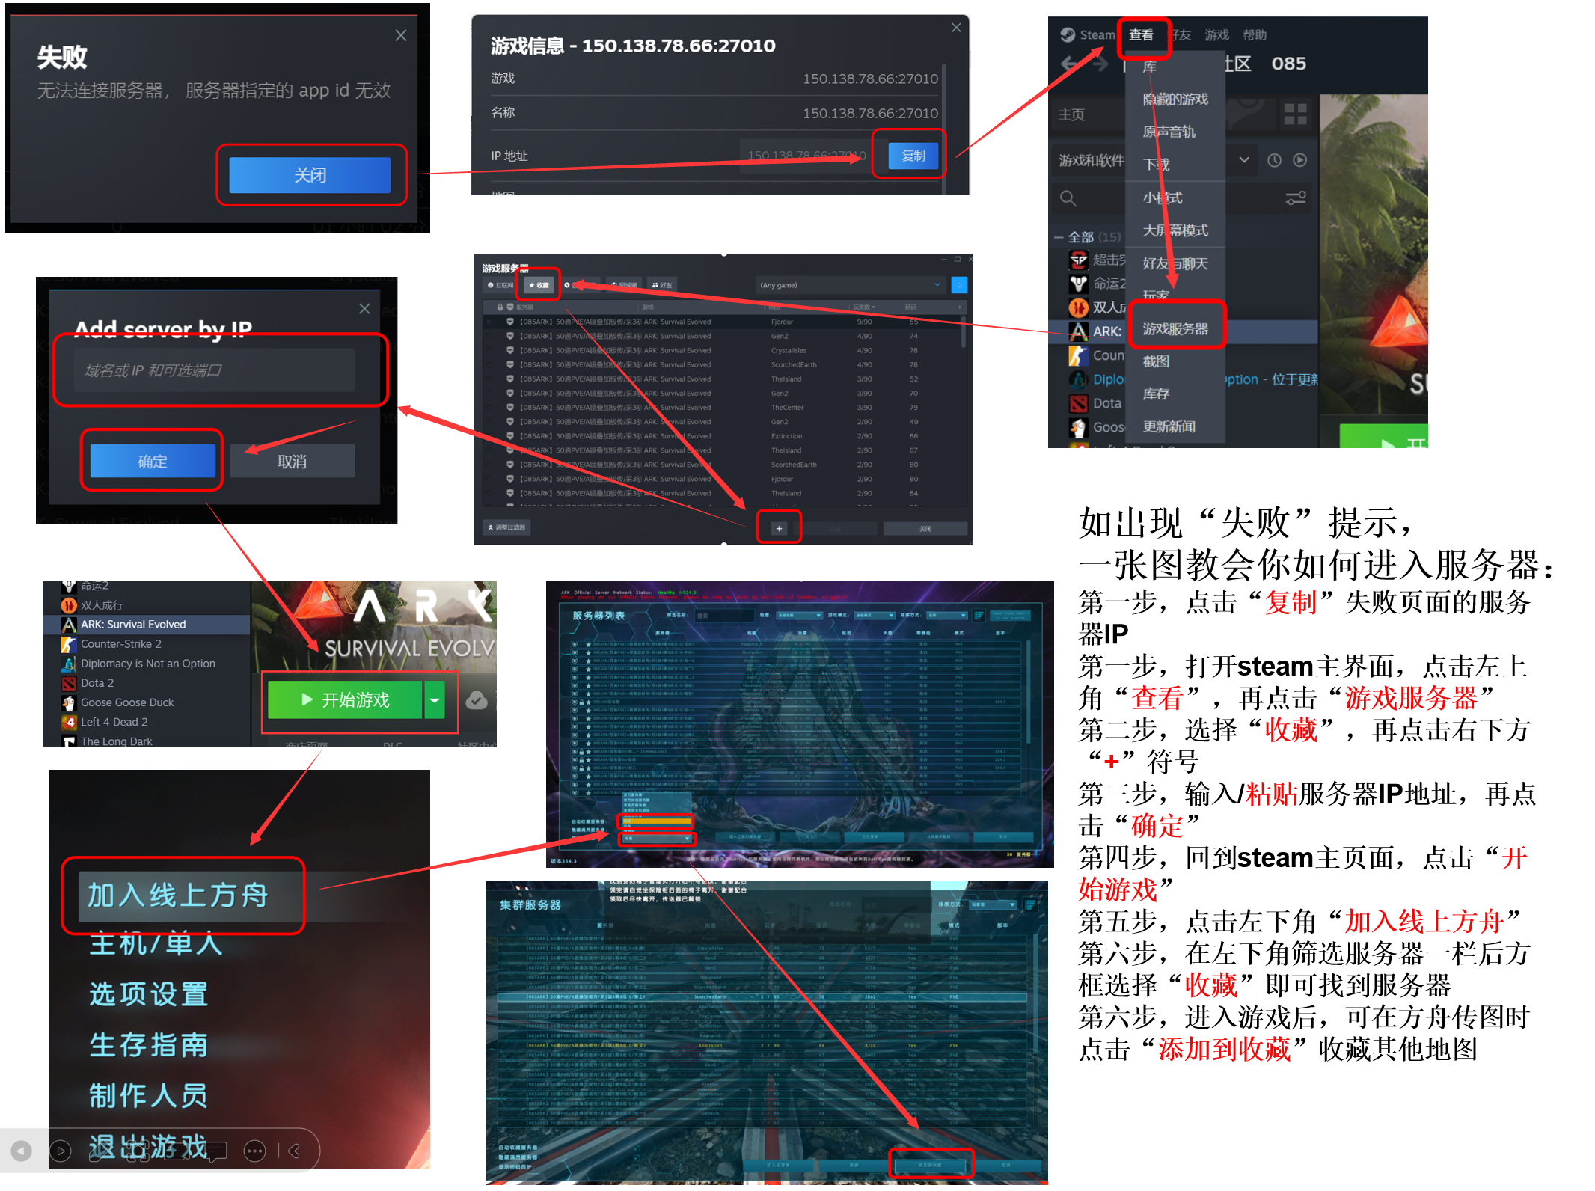
服务器IP地址集合
地图 | IP地址
孤岛1 | 150.138.78.66:27010
孤岛2 | 150.138.78.66:27020
孤岛3 | 150.138.78.66:27030
孤岛4 | 150.138.92.212:28110
孤岛5 | 150.138.92.212:28120
孤岛6 | 150.138.92.212:28130
孤岛7 | 150.138.92.212:28140
焦土1 | 150.138.78.66:27110
焦土2 | 150.138.78.66:27120
焦土3 | 150.138.92.212:28310
焦土4 | 150.138.92.212:28320
畸变1 | 150.138.78.66:27210
畸变2 | 150.138.78.66:27220
畸变3 | 150.138.78.66:27230
畸变4 | 150.138.78.66:27240
畸变5 | 150.138.92.212:28510
畸变6 | 150.138.92.212:28520
畸变7 | 150.138.92.212:28530
畸变8 | 150.138.92.212:28540
灭绝1 | 150.138.78.66:27310
灭绝2 | 150.138.78.66:27320
灭绝3 | 150.138.78.66:27330
灭绝4 | 150.138.78.66:27340
灭绝5 | 150.138.92.212:28710
灭绝6 | 150.138.92.212:28720
灭绝7 | 150.138.92.212:28730
创世纪一1 | 150.138.78.66:27410
创世纪一2 | 150.138.78.66:27420
创世纪一3 | 150.138.92.212:28910
创世纪一4 | 150.138.92.212:28920
创一任务专图 | 150.138.92.212:28930
创世纪二1 | 150.138.78.66:27510
创世纪二2 | 150.138.78.66:27520
创世纪二3 | 150.138.78.66:27530
创世纪二4 | 150.138.78.66:27540
创世纪二5 | 150.138.92.212:29210
创世纪二6 | 150.138.92.212:29220
创世纪二7 | 150.138.92.212:29230
仙境1 | 150.138.78.66:27610
仙境2 | 150.138.78.66:27620
仙境3 | 150.138.78.66:27630
仙境4 | 150.138.78.66:27640
仙境5 | 150.138.92.212:28410
仙境6 | 150.138.92.212:28420
仙境7 | 150.138.92.212:28430
仙境8 | 150.138.92.212:28440
瓦尔盖罗1 | 150.138.78.66:27710
瓦尔盖罗2 | 150.138.78.66:27720
瓦尔盖罗3 | 150.138.78.66:27730
瓦尔盖罗4 | 150.138.92.212:28610
瓦尔盖罗5 | 150.138.92.212:28620
水晶岛1 | 150.138.78.66:27810
水晶岛2 | 150.138.78.66:27820
水晶岛3 | 150.138.92.212:28810
水晶岛4 | 150.138.92.212:28820
水晶岛5 | 150.138.92.212:28830
中心岛1 | 150.138.78.66:27910
中心岛2 | 150.138.78.66:27920
中心岛3 | 150.138.78.66:27930
中心岛4 | 150.138.92.212:28210
中心岛5 | 150.138.92.212:28220
迷失岛1 | 150.138.78.66:29010
迷失岛2 | 150.138.92.212:29010
维京岛1 | 150.138.78.66:30010
维京岛2 | 150.138.78.66:30020
维京岛3 | 150.138.78.66:30030
维京岛4 | 150.138.92.212:29110
维京岛5 | 150.138.92.212:29120
维京岛6 | 150.138.92.212:29130
专属01-15： | 150.138.78.66:（28000+专属号*5）
专属16-XX： | 150.138.92.212:（29300+（专属号-15）*10）
活动地图 | 150.138.92.212:30000

